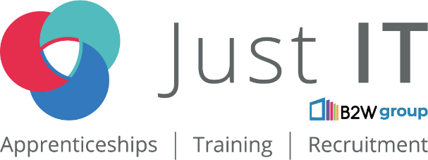

**Data Technician**

|  |
| --- |
|  |

|  |
| --- |
| Name: Mumin Hassan |
| Course Date:12 May 2025 |
|  |

**Table of contents**

Day 1: Task 1 3

Day 1: Task 2 3

Day 1: Task 3 4

Day 2: Task 1 5

Day 3: Task 1 9

Day 3: Task 2 10

Day 3: Task 3 11

Day 4: Task 1 12

Day 4: Task 2 13

1. Scenario Background 13

2. Data Laws and Regulations 14

3. Azure Service Recommendations 14

4. Data Types and Data Modelling 14

5. Data Storage Formats and Structures in Azure 14

6. Additional Considerations 15

Submission Guidelines: 15

Course Notes 17

Additional Information 17

# Day 1: Task 1

Please research and complete the below questions relating to key concepts of cloud.

Be prepared to discuss the below in the group following this task.

|  |  |
| --- | --- |
| What can cloud computing do for us in the real-world? | The cloud computing allows organization or individuals to store data and run applications over the internet without using your own physical hardware storage. You can access files and software from any devices, its automatic backup and update software and in demand computing powers for massive data storage also data analysis. |
| How can it benefit a business? | The cloud computing benefits to business are Cost savings in cloud computing mean reducing the cost of owning the physical hardware and maintaining software and infrastructure by using cloud services. Real-World Example Netflix moved from traditional data centres to the cloud, AWS, to improve scalability and reduce costs. By using cloud services: Netflix doesn't need to buy and maintain its servers. It automatically scales up during high demand and scales down when demand is low, saving money. Cloud computing security offers strong encryption and has data backups, the scalability example business can scale up on their services or scale down based on their currents needs or demands, It also offers flexibility and remote work the business employees can access cloud computing from anywhere. |
| What’s the alternative to cloud computing? | The alternative to cloud computing is installing the physical severs data into the premises of the company. They would need to hire specialist team to manage and run maintenance which is expensive specially since you have also pay physical hardware upfront. Also, it doesn't offer flexibility and cannot be access from multiple locations. |
| What cloud providers can we use, what are their features and functions? | The cloud computing features are Amazon Web Services, Microsoft Azure, IBM Cloud, and Google Cloud Platform.   * Amazon Web Services features are data storages, data bases, and machine learning. AWS is known for its scalability and is used large industries. The function is that it helps organisations run their websites or their application and store the data securely. * Google Cloud platform features AI, machine learning and include data bases. They are well known for having fast and integration with Google services like Google Drive or Gmail. The functions are it help organisations run quickly their application, being able to analyse data, and training AI models * Microsoft Azure features AI, machine learning and include services data bases, virtual machines, and app services. The function mostly helps with app development, cloud hosting, and data analysis. |

# Day 1: Task 2

Please research the below cloud offerings, explain what they are and examples of use cases.

|  |  |  |
| --- | --- | --- |
| Cloud Offerings | Explain what it is | When / how might you use this service in the real-world? |
| IaaS (Infrastructure as a service) | It a service model that provide computing resource like data storage, services, and networking. | You might use IaaS when setting up a virtual server for hosting a website or application without needing to buy physical hardware. an example is AWS EC2. |
| PaaS (Platform as a service) | It's a cloud platform that provides physical hardware and software tool for applications Devlopment. | Used by developers to build apps without managing infrastructure. for example Google App Engine is used for building and deploying apps. |
| SaaS (Software as a service) | It's a software model that doesn't need to install in the computer but is used over the internet and you can access it through only subscription. | Commonly used for email, document editing, or CRM systems. For example, using Microsoft 365 or Google Docs in your daily work. |

# Day 1: Task 3

Please research the below terms and explain what they are, when they would be appropriate and a real-world example of where it could be implemented (i.e. what type of organisation).

|  |  |
| --- | --- |
| Public Cloud | The public Cloud services offered over the internet by third-party providers. Its Suitable for small businesses or startups that want scalable, cost-effective services. For example a startup using Google Cloud for web hosting is a good example. |
| Private Cloud | The private cloud environment used exclusively by one organization. Ideal for businesses needing high security and control. for example A bank using a private cloud to handle customer financial data. |
| Hybrid Cloud | The hybrid cloud combines the public and private clouds to allow data and apps to be shared between them. This is great for organizations that need both scalability and data privacy. For instance, a hospital using a private cloud for patient data and a public cloud for less sensitive operations. |
| Community Cloud | A shared cloud infrastructure is used by several organizations with common goals or compliance needs. For example several government agencies sharing a community cloud for collaborative projects. |

# Day 2: Task 1

Describe, with examples, the **three** major areas that the Computer Misuse Act deals with.

|  |  |  |
| --- | --- | --- |
| Area | Description | Example |
| Unauthorised access to computer systems | When someone is accessing a computer or the system without the owner permission. | An artist hack in their competitive computer system to steel music that is seen by public yet. |
| Unauthorised modification of computer material | It's when someone on purposely changes, deleting, and corrupting files. | An employee installs a virus on the organisation network. |
| Unauthorised access with intent to commit further offences | It's when someone Accessing a system to carry out a more serious crime like fraud. | When a person hack into bank internal system to steel customer account informations. |

The computer misuse act 1990 is an act where an individual can be criminalised because of computer related offense. Describe three extra powers that the Police and Justice Act 2006 (Computer Misuse) has added.

|  |
| --- |
| Description |
| Makes denial-of-service (DoS) attacks illegal. it a criminal offence to deliberately block access to websites, disrupting normal service for users. |
| The increases of penalties for serious computer crimes could go up to 10 year's imprisonment. |
| Criminalises the creation and distribution of tools used for hacking like viruses and malware. |

Look at the below website to answer the questions:

<https://www.gov.uk/personal-data-my-employer-can-keep-about-me>

|  |
| --- |
| Write down three items of data which a company can store about an employee. |
| 1, The full name and contact detail of employees. |
| 2, Employment history their qualification. |
| 3, The Record of the employees like how long they been with the company and the type of contract they have. |

|  |
| --- |
| Give three more examples of data that an employer can only store if they first get the employee’s permission. |
| 1, The biometric data like facial recognition or fingerprints. |
| 2,The health information of the employee or their medical records. |
| 3, Cultural background or ethnicity Especially if used for diversity tracking. |

Conduct further research to answer the below questions.

|  |  |
| --- | --- |
| Question | Answer |
| Provide one example of: Copyright infringement | Downloading or sharing a movie without paying for it. |
| Provide one example of: Plagiarism | Copying a paragraph from an article and submitting it as your own work in an assignment. |
| What are two consequences of copyright infringement and software piracy? | First is legal actions and fines and the second one is the reputation of company is damage to public eye. |
| Give three possible consequences for individuals when using pirated software | First is the risk of viruses, second one is legal prosecution, third one is no customer support since it's not legal. |

Listed below are some laws which we have covered today:

1. Computer Misuse Act 1990

2. Police and Justice Act 2006 (Computer Misuse)

3. Copyright, Designs and Patents Act 1988

4. Copyright (Computer Programs) Regulations 1992

5. The Health and Safety (Display Screen Equipment) Regulations 1992

6. Data Protection Act 2018

7. Consumer Rights Act 2015

* Insert a number in the first column of each row to match each of the statements with one of the above Acts.
* One of statements is incorrect and not illegal. For this statement, write ‘Not illegal’.

|  |  |
| --- | --- |
| **Act number** | **Clause** |
| 4 | With some exceptions, it is illegal to use unlicensed software |
| 7 | Any product, digital or otherwise, must be fit for the purpose it is supplied for |
| 1 | Unauthorised modification of computer material is illegal |
| Not illegal | It is illegal to create or use a hacking tool for penetration testing |
| 6 | Personal data may only be used for specified, explicit purposes |
| 5 | Employers must provide their computer users with adequate health and safety training for any workstation they work at |
| 2 | It is illegal to distribute hacking tools for criminal purposes |
| 3 | It is illegal to distribute an illicit recording |
| 6 | Personal data may not be kept longer than necessary |
| 1 | Gaining unauthorised access to a computer system is illegal |
| 5 | Employers must ensure that employees take regular and adequate breaks from looking at their screens |
| 2 | It is illegal to prevent or hinder access (e.g. by a denial-of-service attack) to any program or data held in any computer |
| 6 | Personal data must be accurate and where necessary kept up to date |

# Day 3: Task 1

Please complete the below lab (3) *‘Explore relational data in Azure’* and paste evidence of the completed lab in the box provided.

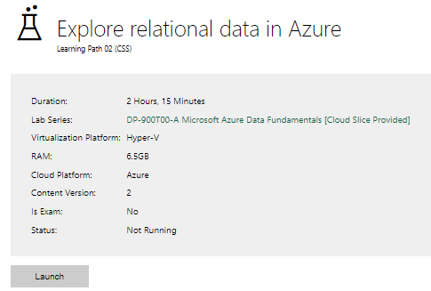

|  |  |
| --- | --- |
| Completed lab |  |

# Day 3: Task 2

Please complete the below lab (4) *‘Explore non-relational data in Azure’* and paste evidence of the completed lab in the box provided.

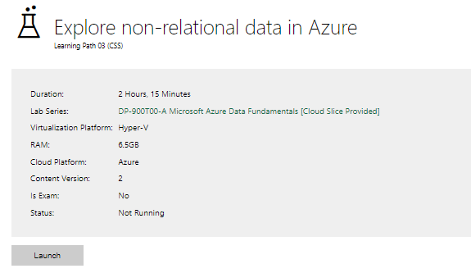

|  |  |
| --- | --- |
| Completed lab |  |

# Day 3: Task 3

Please complete the below lab (5) ‘Explore data analytics in Azure’ and paste evidence of the completed lab in the box provided.

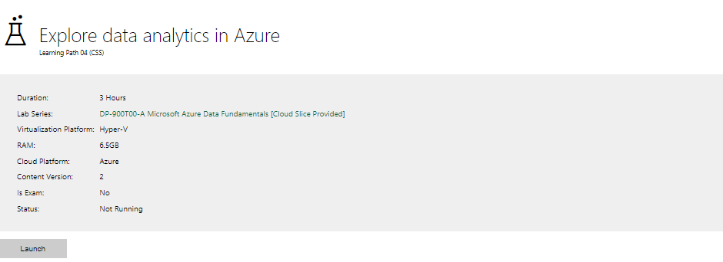

|  |  |
| --- | --- |
| Completed lab |  |

# Day 4: Task 1

In your teams, complete the Azure DP-900 practice exam and paste your result below – this is open book and please research and discuss your answers as a team.

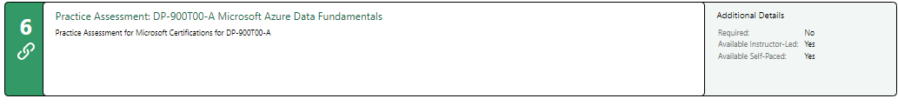

|  |  |
| --- | --- |
| Result |  |

# Day 4: Task 2

#### **1. Scenario Background**

"Paws & Whiskers" is a growing pet shop that aims to improve its business by analysing sales, customer information, and inventory data. Currently, the data is collected manually or stored in spreadsheets. Management is interested in transitioning to Microsoft Azure to streamline data storage, analysis, and reporting, enabling them to make data-driven decisions.

#### **2. Data Laws and Regulations**

Identify and explain the data laws and regulations relevant to handling customer data within the proposal. Ensure you cover the following points:

* **GDPR Compliance**: Highlight the importance of adhering to the General Data Protection Regulation (GDPR), particularly as it relates to storing and processing customer information.
* **Data Protection Act (DPA) 2018**: Outline how the DPA 2018 may affect the way "Paws & Whiskers" collects and stores data, ensuring compliance with UK laws on data privacy.
* **Other Industry Standards**: Research any additional data protection standards or regulations that may apply to pet shop data, particularly if they involve sensitive or payment information.

#### **3. Azure Service Recommendations**

Recommend Microsoft Azure services that would suit the company’s data analysis needs and explain why these services are suitable. Your recommendations should include:

* **Data Storage**: Identify suitable storage options, such as **Azure Blob Storage** or **Azure SQL Database**, and discuss the benefits of each for storing large datasets, including inventory, sales transactions, and customer details.
* **Data Analysis Tools**: Recommend tools such as **Azure Machine Learning** for customer behaviour analysis or **Azure Synapse Analytics** for analysing sales trends.
* **Data Integration and Automation**: Explain how services like **Azure Data Factory** could automate data collection and integration processes, improving efficiency.

#### **4. Data Types and Data Modelling**

Define the types of data "Paws & Whiskers" will need to work with and describe your approach to data modelling:

* **Data Categories**: Identify key data types, such as customer demographics, transaction history, pet inventory, and product categories.
* **Data Modelling Approach**: Outline how you would structure this data using a relational model or a data warehouse approach, considering factors like tables, entities, relationships, and primary keys.

#### **5. Data Storage Formats and Structures in Azure**

Discuss how you would store data within Azure and the formats you would recommend:

* **Data Formats**: Specify recommended formats (e.g., CSV for raw data imports, JSON for structured data, Parquet for analytics) and explain why these formats are suitable for specific data types.
* **Data Security and Encryption**: Include recommendations for securing data using Azure’s built-in encryption features and access controls to ensure compliance with data privacy regulations.

#### **6. Additional Considerations**

Provide any other considerations that might enhance data handling and efficiency in Azure, such as:

* **Backup and Disaster Recovery**: Outline a backup plan using **Azure Backup** or **Azure Site Recovery** to safeguard against data loss.
* **Data Visualisation**: Discuss potential use of **Power BI** within Azure for creating dashboards that provide management with real-time insights into sales and customer trends.
* **Future Scalability**: Comment on how Azure services can scale as the business grows, accommodating larger datasets and more complex analyses.

### **Submission Guidelines:**

1. **Structure**: Ensure your report is well-organised, with sections for each task (e.g., Data Laws, Azure Services, Data Types, etc.).
2. **Formatting**: Include headings, bullet points where appropriate, and any visuals or diagrams that support your explanations.
3. **References**: Cite any resources or regulations referenced in the report.
4. **Length**: Aim for 1500-2000 words.

|  |
| --- |
| Paws & Whiskers Azure Data Strategy Report  1, Data Laws and Regulations:  The General data protection regulation is one of the important key legislations for businesses it handles the personal data of the EU and UK. It's very important to follow the GDPR compliance on how we use customer data like name, home address, email address, store data, and how we handle the data because it governs the data.   * Lawfulness, fairness, and transparency, all customers must be informed on how we are going to use their personal information. * Storage limitation, currently there no time limit on data but it should be erased when the data is no longer useful. * Confidentiality and integrity, the customers data need to be encrypt against hackers or people that is not allowed to accesses it.   The Data Protection Act 2018  The data protection act 2018 is the UK version of GDPR it regulates organizations how they store data, collect data, and how they customers personal information. For Paws & Whiskers it means they need to   * The customers must give consent to the organisation before their data is taken. * The customers have the right to access their personal data or to delete their personal data from the organisation. * The customers data activities need to be recorded or documented.   2, Azure Service Recommendations:  Data storage   * Azure blob storage is perfect for storing massive amount of data into the cloud and it stores the data instructed. * Azure SQL Database is best for structured data like inventory list, and customer transaction records. It's also has SQL which would be easy to analyses the data while it in the cloud.   The benefits of cloud computing:   * The ability to scale up or lower quickly depend on the business demands. * The regular's updates and servers improvement. * The automatic backup system. * The integration with analytic tools and other services the business could use if needed.   Data Integration and Automation   * Azure Data Factory is a data integration service that allow the user to create automate data movement, and transformation. The data automate is very usefull tool for analyst to use for data extraction from spreadsheets.   Data analysis tools   * Azure Synapse Analytics is cloud-based analytics service it's great for analysing large scale of data like trend, inventory, customers patterns. Since its part of Microsoft, you can integrate it with power BI. * Azure Machine Learning is used to predict data behaviour on customers and sales trends and is most accurate when it has large data.   3, Data Types and Data Modelling:  Data Categories   * Customer info is Name, age, contact details, pet ownership      * Transaction Records: Dates, items purchased, payment method, amount * Pet Inventory: Pet type, breed, health status, availability * Product Categories: Pet food, toys, grooming items, accessories   Entity Relationship Design:     * Customers Table, CustomerID (PK), Name, Email, Phone      * Transactions Table, TransactionID (PK), CustomerID (FK), Date, Total      * Products Table, ProductID (PK), CategoryID (FK), Name, Price, Stock      * Categories Table, CategoryID (PK), CategoryName      * Pets Table, PetID (PK), Type, Breed, Status   4, Data Storage Formats and Structures in Azure:  Data Formats types   * CSV, is a plain text file format its used for raw data imports from spreadsheets like excel.   An example is  Name, Age, City  Mumin, 20, London  Ayaan, 25, Manchester   * JSON, is lightweight data format and is used to represent structured data its used for data exchange between application.   An example is  {"name": "Mumin",  "age": 20,  "city": "London",  "skills": ["Python", "SQL", "Power BI"]}  The recommendation is to store the data in Azure SQL Database, archive data in parquet format while using Azure data storage gen2. The reason I choose parquet format it can store large number of datasets which good for organizations and it is efficient format compared to the others one.  The data security is very important for us to have the trust of customers personal information is safe. The Azure encryption ensures that there could data is secured and safe from breaches and unauthorised access.  5, Additional Considerations:  Data backups,   * Azure automatically saves or backups the datasets in different sever to ensure if one fail the backup sever will be used then.   Data Visualisation,   * Power BI is integrated with azure service because Microsoft application or services are link, and you can create dashboard reports for the business   References are:  UK GDPR Guide  <https://ico.org.uk/media/for-organisations/guide-to-data-protection/guide-to-the-general-data-protection-regulation-gdpr-1-1.pdf>  Data Protection Act 2018 <https://www.legislation.gov.uk/ukpga/2018/12/contents/enacted> |

|  |
| --- |
| **Course Notes** |

It is recommended to take notes from the course, use the space below to do so, or use the revision guide shared with the class:

|  |
| --- |
| **Additional Information** |

We have included a range of additional links to further resources and information that you may find useful, these can be found within your revision guide.

**END OF WORKBOOK**

**Please check through your work thoroughly before submitting and update the table of contents if required.**

**Please send your completed work booklet to your trainer.**